Kogge-Stone Adder
Gonzalo de Rojas (A17930133), Minh Nghi Mac (A17227502), Elisha Sengupta (A17466620)t
Adders are one of the most fundamental operations performed in digital design, serving as a core building block for binary arithmetic operations in microprocessors, arithmetic logic units (ALUs), digital system processors (DSPs), and many other computational systems. Since arithmetic operations are performed continuously during program execution, the performance of an adder is crucial for the operating speed of an entire system. The demand for higher clock frequencies and lower power consumption changes, optimization of adders becomes very important. The objective of this project was to design a custom 8-bit CMOS adder capable of operating at significantly higher speeds than a traditional synthesized design while maintaining the functionality and keeping the power consumption to a minimum. The primary design challenge is to do this while minimizing carry propagation delay as the signal moves through different stages before the final result.
To address this, we wanted to follow an architecture that computes carry signals in parallel rather than sequentially. Traditional adder architectures, such as ripple-carry, carry-skip, and carry-select, although they are easier to design, require the bits to pass through multiple stages to obtain the result, which increases overall delay. We selected the Kogge-Stone adder because of its parallel-prefix architecture, designed to minimize carry propagation delay. Among other parallel-prefix architectures, the Kogge-Stone adder offers one of the lowest logic depths with approximately $\log_{2}(N)$ stages in the entire structure, resulting in a shorter critical path and therefore lowering overall delay. Additionally, each cell drives about 2-3 gates, resulting in low fan-out and reduced capacitive loading. This allows faster switching, improving propagation speed, and enabling operation at higher clock frequencies.
The Kogge-Stone adder consists of three stages: pre-processing, carry generation, and post-processing. During the pre-processing stage, the propagate(Pi) and generate (Gi) are calculated for each input bit pair using,
$P_{i}$ = $A_{i}$ XOR $B_{i}$
$G_{i}$ = $A_{i}$ AND $B_{i}$
These signals determine whether a bit position will propagate an incoming carry or generate a new carry. The carry generation stage is where propagate-generated cells determine carry signals across multiple stages in parallel.
$G_{i}$ = ($P_{i}$ AND $G_{i*}$) OR $G_{i}$
$P_{i}$ = ($P_{i}$ AND $P_{i*}$ )
In the post-processing stage, the calculated carry signals are combined with the propagate signals to produce the final sum output.
$C_{i}$ = $G_{i}$
$S_{i}$ = $P_{i}$ XOR $C_{i-1}$
In this project, we were able to custom design and optimize each stage at the gate and translator level in Cadence Virtuoso to achieve high speed operation and reduce critical path delay.
The most innovative aspect of this project was the methodology used to design and optimize the adder. Rather than relying on pre-designed standard cells, we first designed our own logic gates at the transistor level and used these custom gates to construct the logic cells required for each stage of the adder. This provided greater insight into the circuit operation and allowed us to build a fully functional adder using components tailored to our design. Once the initial adder was completed, a critical-path analysis was performed to identify cells contributing the greatest delay. We then replaced those cells with a complete transistor-level cell to be able to modify transistor sizing more easily and also eliminated the number of intermediate gates and signal transitions. This helped us to reduce the delay and by focusing on the most timing-critical portions of the design, we achieved improved performance. Our adder currently operates up to 3765MHz.
Our current design was optimized as extensively as possible within the scope of the chosen architecture. Through critical-path analysis and transistor-level optimization, the delay of the most timing-critical cells was minimized to achieve the highest possible operating speed. While replacing all the other cells with the same transistor-level implementations could provide mild improvements in delay, achieving a more drastic performance improvement would likely require architectural changes. Exploring a hybrid Kogge-Stone structure with other parallel-prefix adders could provide more desirable results. Additionally, if larger output loads were present, further optimization through buffer insertion and driver sizing could be used to improve overall performance.
The design, implementation, and optimization of the Kogge-Stone adder were divided among the three team members. Gonzalo de Rojas was responsible for the pre-processing stage, Elisha Sengupta was responsible for the carry generation stage, and Minh Nghi Mac was responsible for the post-processing stage. Each team member verified the functionality and performance of their assigned stage to ensure proper operation and efficient integration into the complete design. After the individual stages were validated, Minh Nghi Mac combined the three stages into the final 8-bit Kogge-Stone adder. Gonzalo de Rojas performed the final functional verification and testing to confirm the correct operation of the complete adder, while Elisha Sengupta prepared the final report and documented the design process and results.
Acknowledgments:
The authors would like to thank Professor Patrick Mercier for his teachings and guidance throughout this project. We also extend our appreciation to our course TA’s Zixiao Lin and Mahmoud Kamel.

References:
[1] A. H. Ismail, “Kogge Stone Adder,” YouTube. Available: https://www.youtube.com/watch?v=tgY4UIufLd0

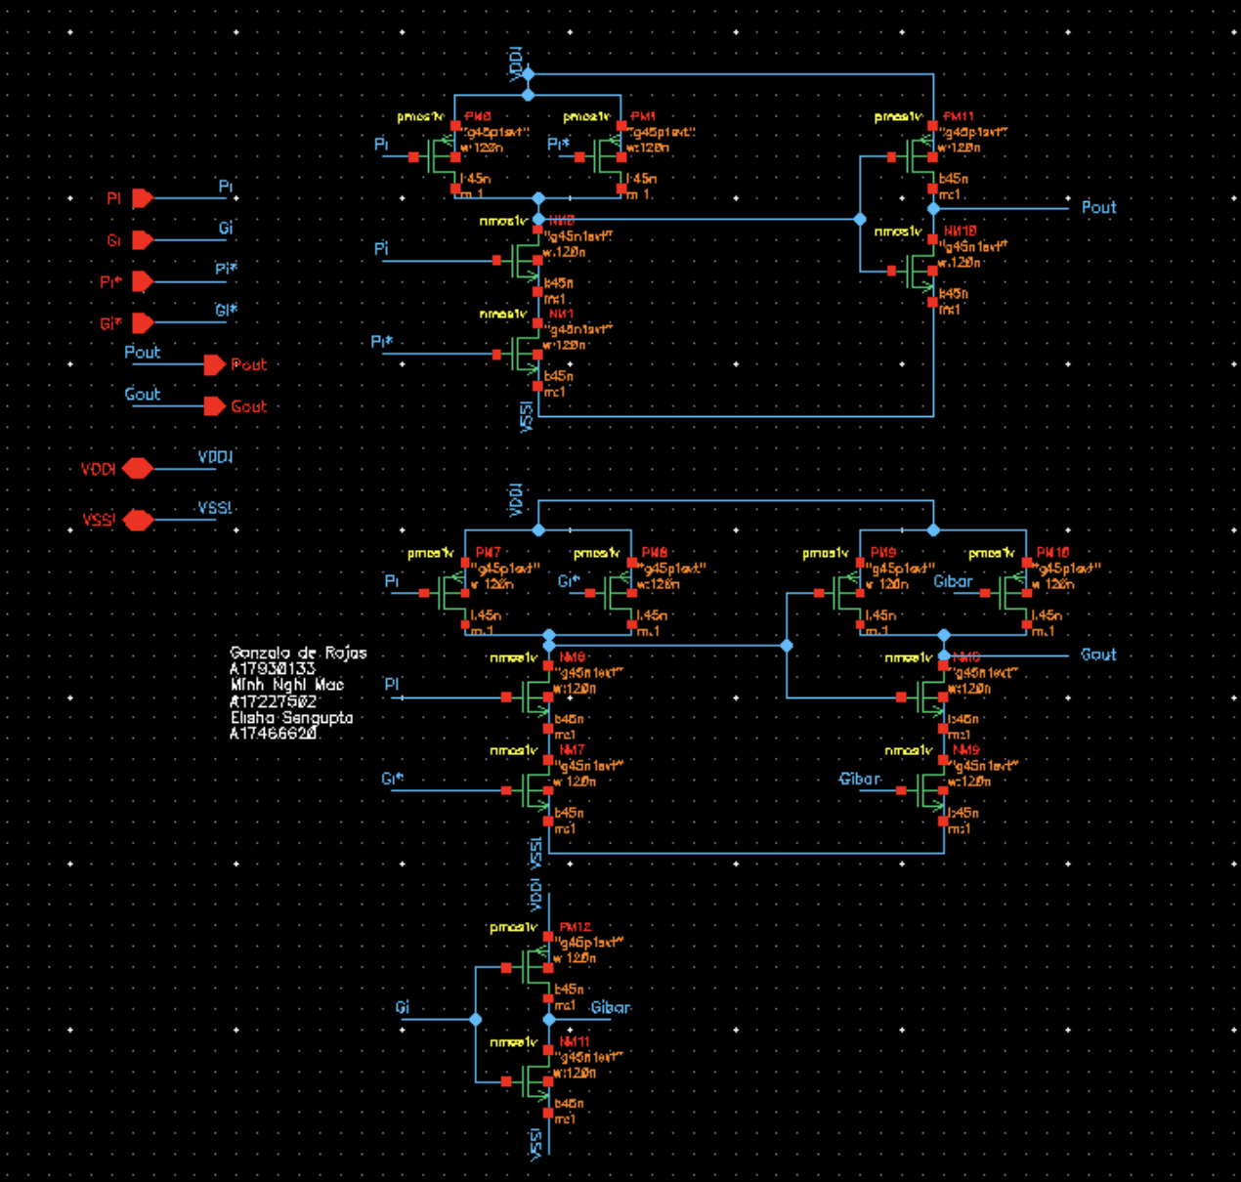
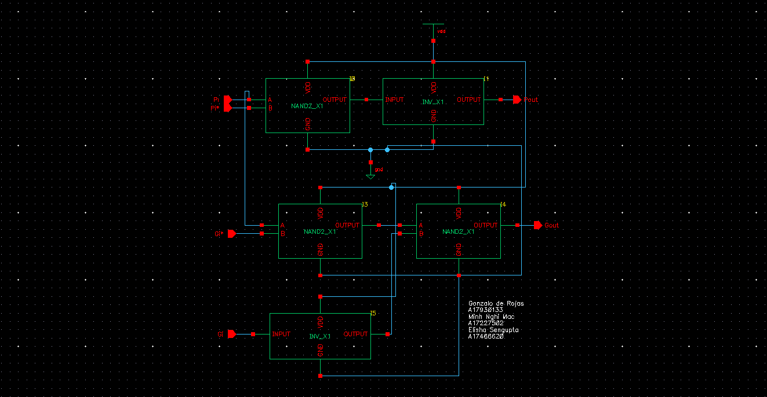
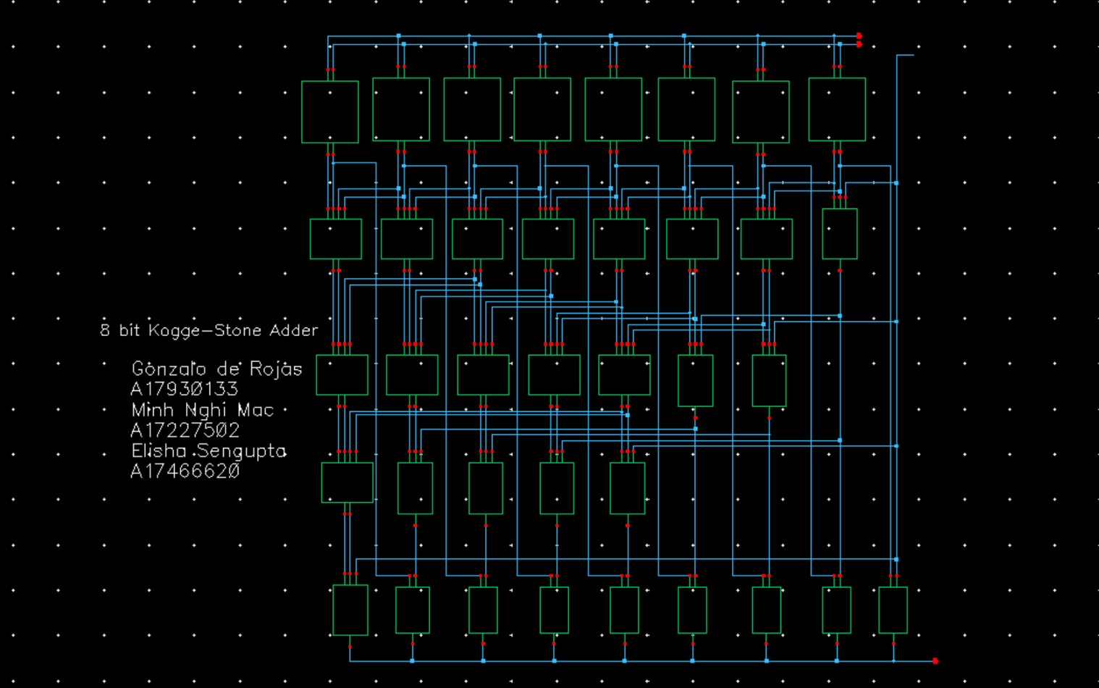
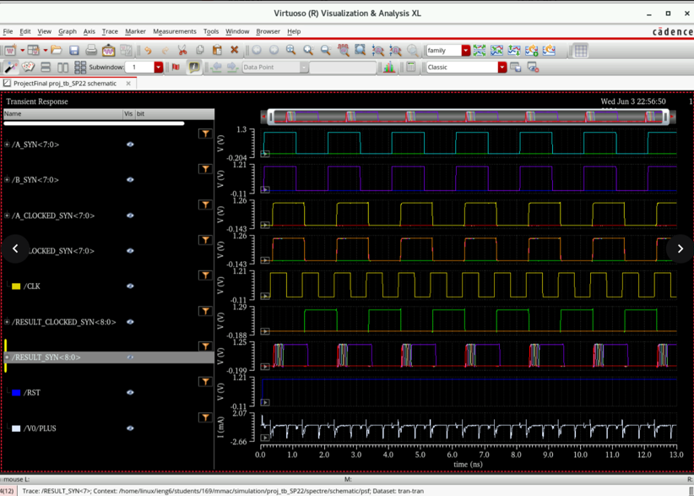
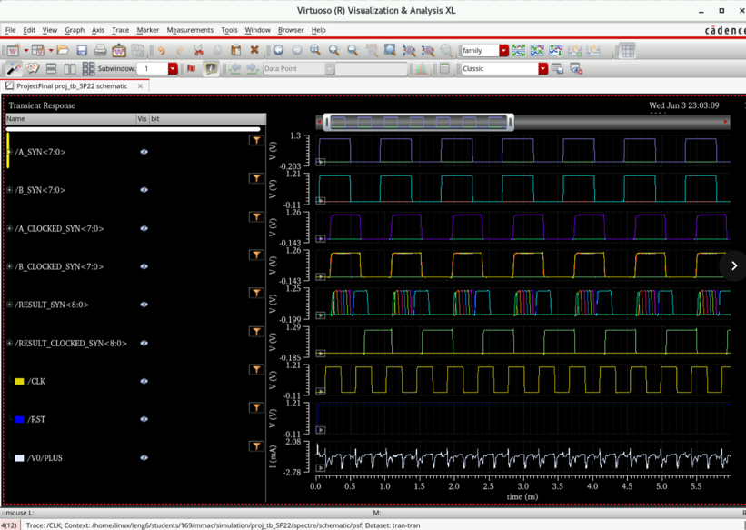
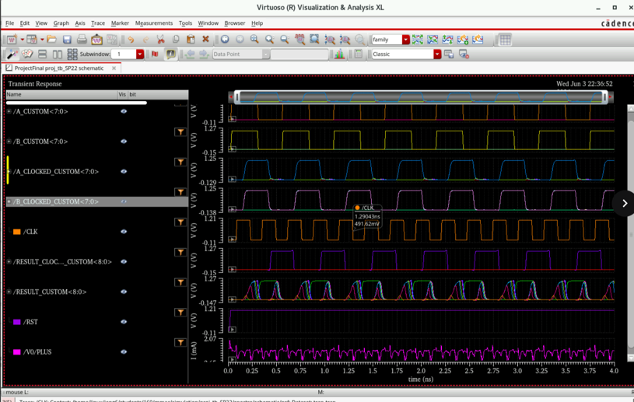
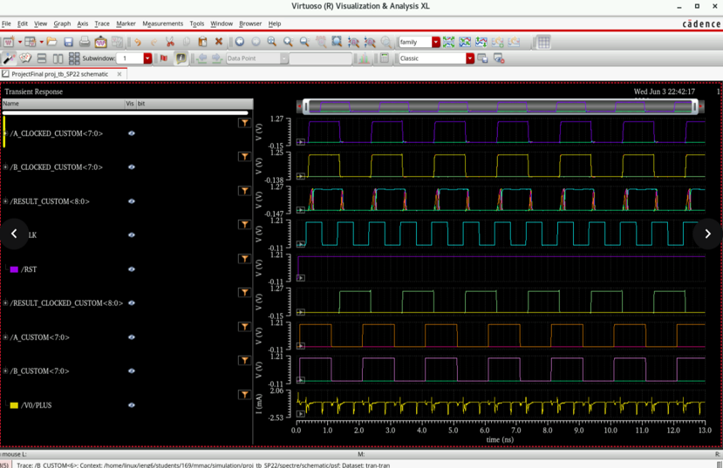
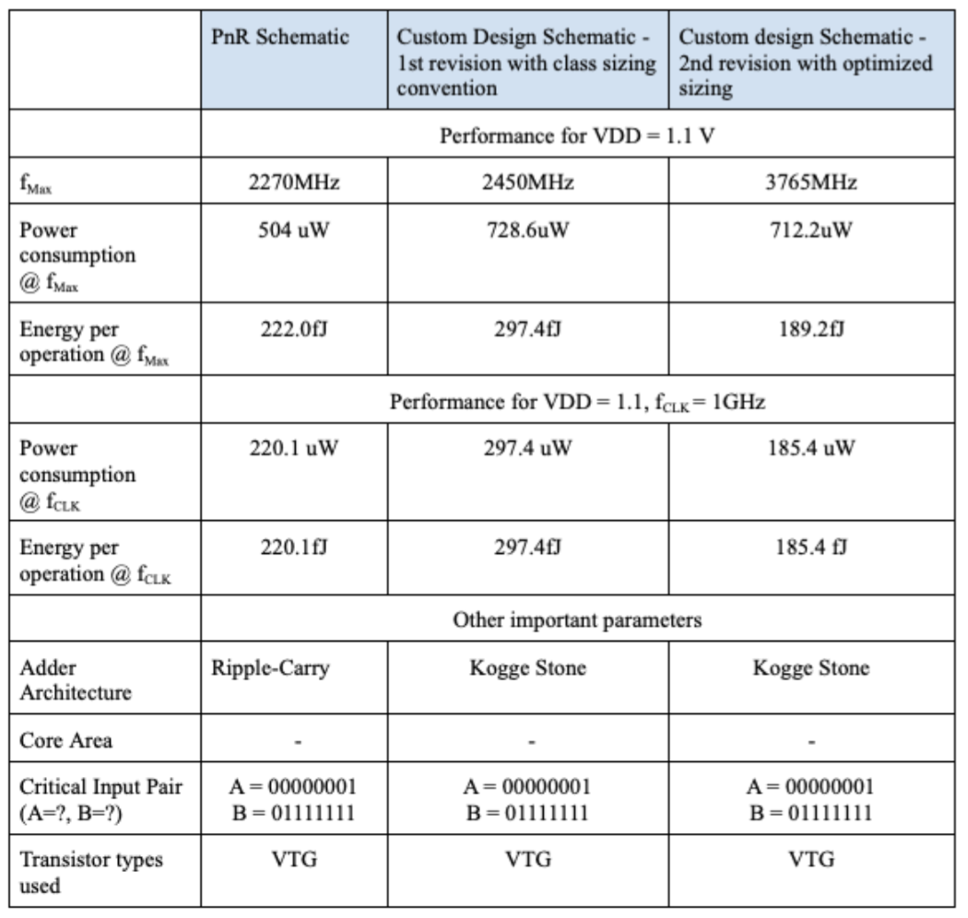
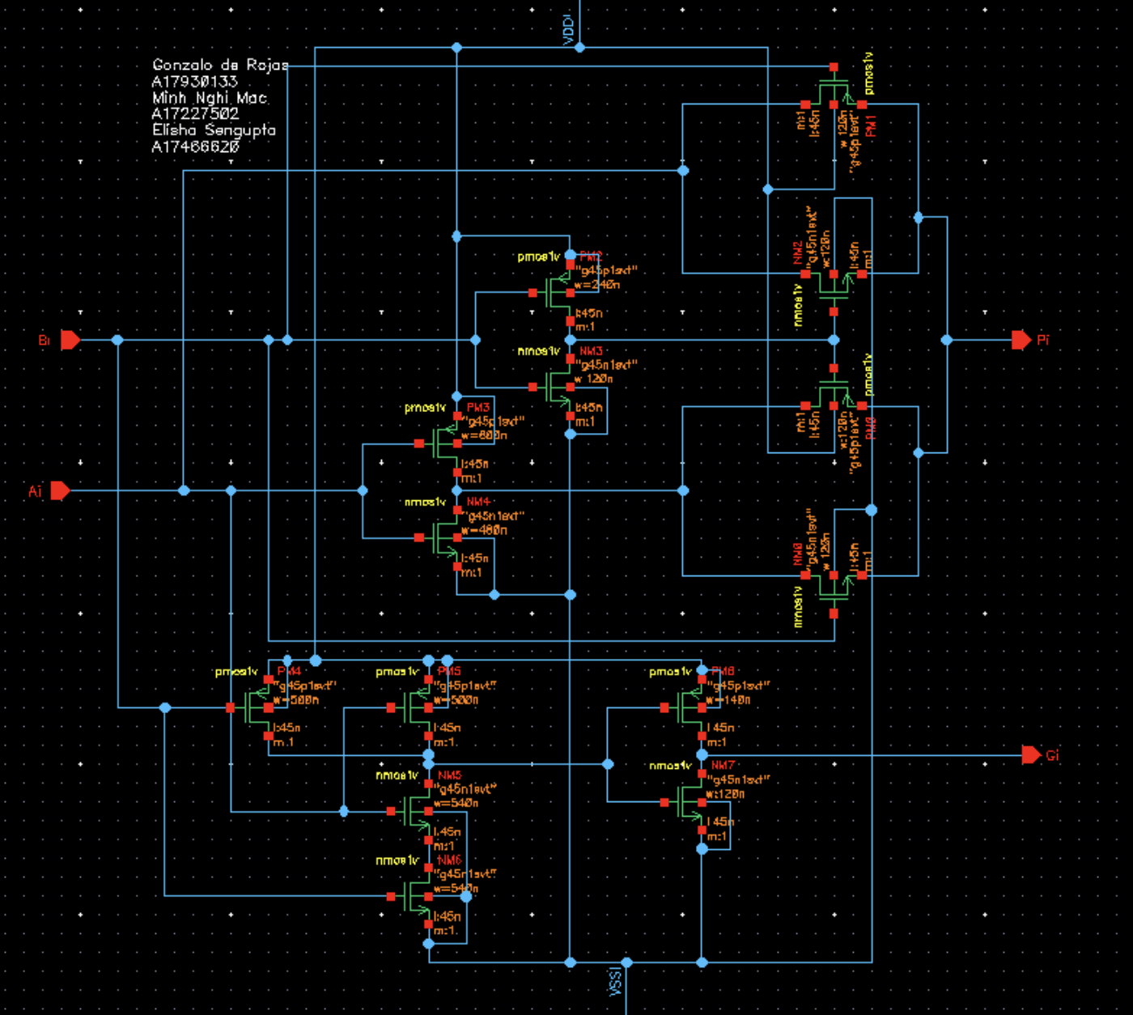
Figure 1 | Schematic of the most repeated cell on the critical path – Transistor-Level Carry Generation Cell
Kogge-Stone Adder Operating at Maximum Frequency of 3765 MHz
Kogge-Stone Adder Operating at Maximum Frequency of 3765 MHz
Figure 2 | Schematic of Gate - Level Carry Generation Cell on non-critical path
Figure 3 | Schematic of 8-bit Kogge-Stone Adder
Synthesized Adder Operating at Frequency of 2270 MHz
Synthesized Adder Operating at Frequency of 1000 MHz
Kogge-Stone Adder Operating at Frequency of 1000 MHz
Kogge-Stone Adder Operating at Frequency of 3765 MHz
Figure 5 | Maximum Operating Frequency Comparison of the Custom and Synthesized 8-Bit Adders
Figure 6 | Table of Performance Results

Figure 7 | Schematic of Transistor-Level Pre-Processing Stage on Critical Path

